School things crosswords

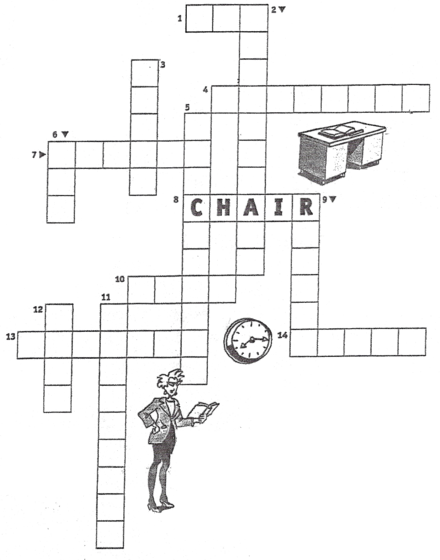

_ _ _



_ _ _ _ _ _ _ _ _



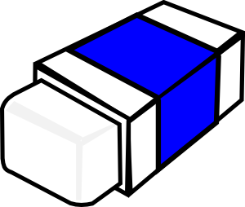

_ _ _ _ _ _

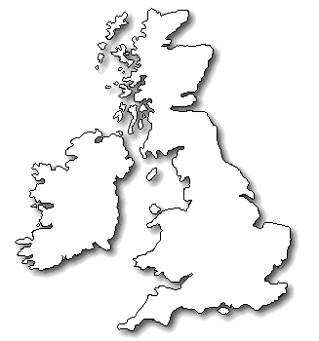 _ _ _

[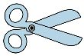](http://www.clipartsxtras.com/clipartsxtras-free-cliparts-details.asp?prodid=24275)

_ _ _ _ _ _ _ _

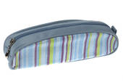

_ _ _ _ _ _

c a s e

_ _ _ _ _ _ _ _ _ _

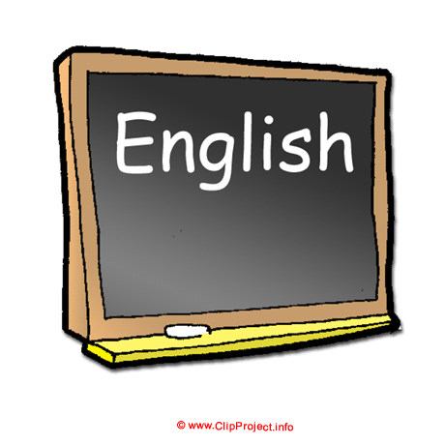

_ _ _ _ _ _ _

_ _ _ _ _



_ _ _ _ _ _

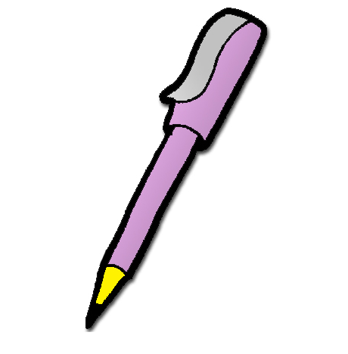

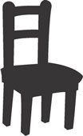

_ _ _ _ _



_ _ _ _

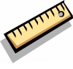

_ _ _ _ _

_ _ _ _

School things crosswords



pen



Schoolbag





rubber

 map

[](http://www.clipartsxtras.com/clipartsxtras-free-cliparts-details.asp?prodid=24275)

scissors



pencil

c a s e

blackboard



Teacher

clock



pencil





Chair



book



ruler

desk