- Use the words to write sentences. Use must (Yes) or mustn’t (No).
  - we / wear / jewellery / at school (No)

  - we / arrive at school / before 8.30 a.m. (Yes)

  - you / take photos / in the museum (No)

  - you / wear / protective clothing (Yes)

  - you / walk / on the grass (No)

- Underline the mistake. Write a correct sentence.
  - We don’t have wear a school uniform.

  - They mustn’t to feed the ducks in the park.

  - We must go swimming in the river. It’s forbidden.

  - They must to park their cars in the car park.

  - You must looking after your pet rabbit.

- Choose the correct words.
  - 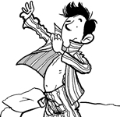
Mr Jones must / doesn't have to get dressed for work.
  - 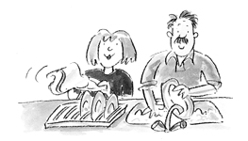
We don’t have to / mustn’t help Mum and Dad do the washing-up.
  - 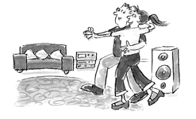
Claudia and Bert must / don’t have to practise for the dance competition.
  - 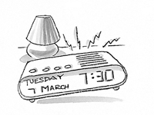
I must / don’t have to get up at 6.30 a.m. today.
  - 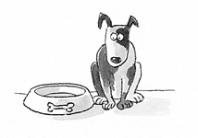
I mustn’t / must feed Rover too much food today. He’s too fat!

Resources: PHOTOCOPIABLE, Project Fourth edition, © Oxford University Press 2016

