ANGLICKÝ JAZYK 7. TŘÍDA – Mgr. Martina Mádrová

- Complete the sentences. Choose A or B.
  - _________ have to wear special space suits in space.
    - ☐ Astronauts
    - ☐ Planets
  - A ________ is a place in space.
    - ☐ rocket
    - ☐ space station
  - _________ is the name of the planet where we live.
    - ☐ Moon
    - ☐ Earth
  - There are lots of _________ in our galaxy.
    - ☐ stars
    - ☐ rockets
  - The Earth goes around the ________ .
    - ☐ Moon
    - ☐ Sun
  - Astronauts travel into space in _________ .
    - ☐ rockets
    - ☐ satellites
  - People don’t live on _________ .
    - ☐ the Moon
    - ☐ space stations
  - __________ orbit the Earth.
    - ☐ Astronauts
    - ☐ Satellites

- Choose the correct word.
  - Astronauts / Rockets travel into and work in space.
  - You can see the Earth / astronauts from space.
  - The Earth travels around stars / the Sun.
  - You can see lots of stars / Moons in the sky at night.
  - There are lots of Earths / satellites in space.
  - There’s an international space station / rocket in space.
  - In the future people will travel to space in satellites / spaceships.
  - The Moon / Sun shines in the night sky.

- Choose the correct words.
  - (Yes)
More people will / won’t explore space.
  - (No)
People will / won’t build cities on the planet Saturn.
  - 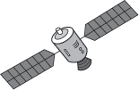 (Yes)
There will / won’t be lots of satellites in space.
  - 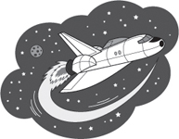 (No)
Pets will / won’t travel on space shuttles.
  - 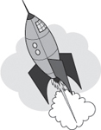 (Yes)
Robots will / won’t fly rockets.
  - (Yes)
Our planet will / won’t be more crowded.
  - (No)
People will / won’t live on the Sun.
  - (Yes)
People will / won’t live on the Moon.

Resources: PHOTOCOPIABLE, Project Fourth edition, © Oxford University Press 2016

