SIMPLE FUTURE – (WILL)
Používej zkrácenou formu : He´ll, I´ll,....
Pracuj s přehledem gramatiky ve WORKBOOK
Na otázky odpověz
Workshheet year 7 Machačová Yvona
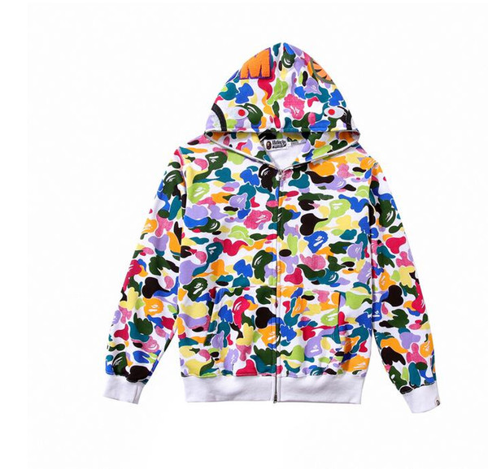
Complete the sentences.
- What _________ you do tomorrow?
………………………………………………………………
- I think she _________ (buy) a colourful coat.
- She _____________ (not eat) junk food because it is unhealthy.
- My father ______________ (drive) us to the holiday place next summer.
- People _____________ (get) fit if they do sports.
- My neighbours are making a lot of noise, I _________ (talk) to them soon.
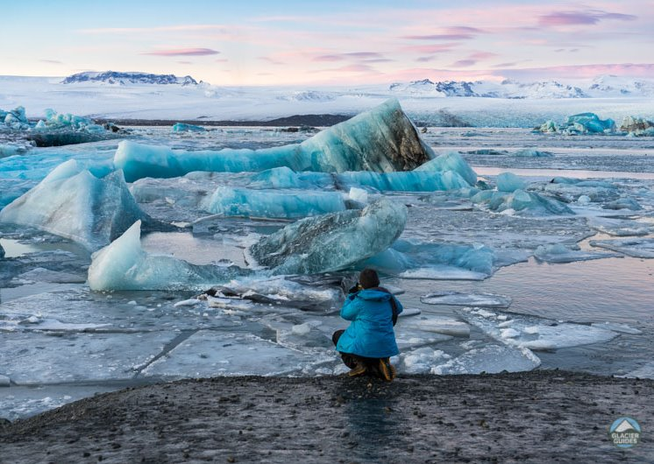
- Next year, we ___________ (travel) to Iceland to see glaciers.
- If you don’t study hard, you __________ (not pass) your exams.
- We ___________ (use) different smart phones in 2030.
- Where ___________ you live in the future?
--------------------------------------------------
--------------------------------------------------

