Napiš cenu k oblečení dole a čísla k oblečení v obrázku. Machačová Y. year 5

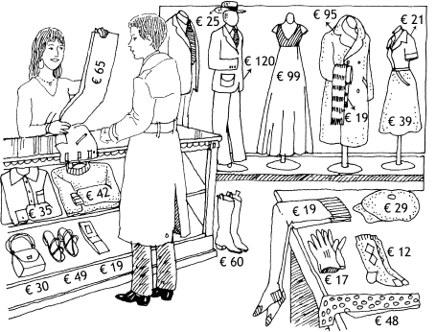

- The belt is.....................................................................................................................
- The boots are...............................................................................................................
- The bag.......................................................................................................................
- The shirt.......................................................................................................................
- The skirt.......................................................................................................................
- The dress.....................................................................................................................
- The coat.......................................................................................................................
- The socks.....................................................................................................................
- The blouse...................................................................................................................
- The stockings ..............................................................................................................
- The gloves ...................................................................................................................
- The cap .......................................................................................................................
- The sweater ................................................................................................................
- The sandals ................................................................................................................
- The hat ........................................................................................................................
- The tie .........................................................................................................................
- 17 The trousers...........................................................................................................
- The suit .......................................................................................................................
- The scarf .....................................................................................................................

