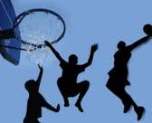

**Machačová Y. Sport quiz**

The piece of wood used for hitting the ball in baseball or cricket:

When a game is finished without either team winning, e.g. 1-1, the game ends in a:

The official who controls the game in some sports, e.g. football is called:

a. draw

b. drawer

c. pair

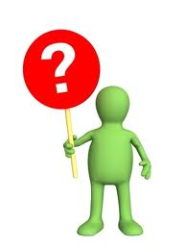

a. arbitrator

b. referee

c. judge

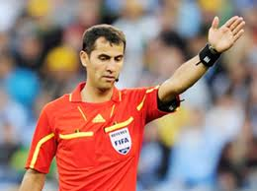

a. racket

b. bat

c. log

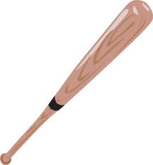

A type of hard hat that protects the head of the players in some sports is:

Who trains a person or team in sport is the:

The long metal stick used for hitting the ball in golf:

a. trainee

b. coach

c. couch

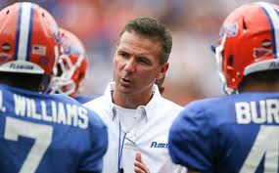

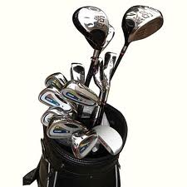

a. golf club

b. golf bat

c. golf iron

a. an armour

b. a helmet

c. a bowler hat

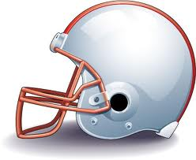

The pair of glasses that fit closely to the face to protect your eyes from water in swimming:

The leader of a sports team is the:

The number 0, especially as the score in some games is called:



a. nil

b. void

c. null

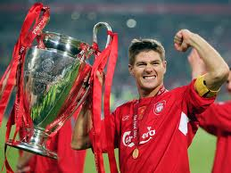

a. boss

b. captain

c. commander

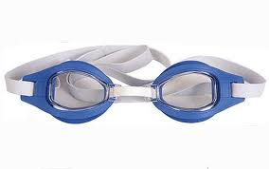

a. googles

b. goggles

c. goblins

The object that players hit backwards and forwards in the game of badminton:

A small metal or plastic tube that you blow to make a sound to attract the players’ attention:

The sticks used to push yourself forward while skiing:

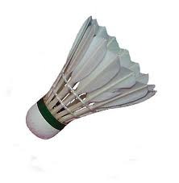

a. shuttle-cock

b. shutter-cock

c. shuffle-cock

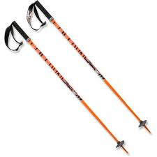

a. ski bats

b. ski posts

c. ski poles

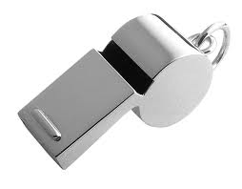

a. whisper

b. whistle

c. whisker

A weapon with a long metal blade and a handle used in fencing:

A game played on ice, in which players slide heavy flat stones towards a mark:

An area of land covered by snow where you can practise skiing:

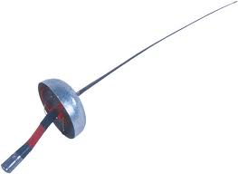

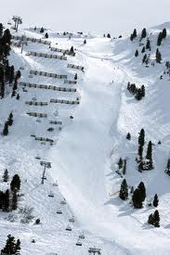

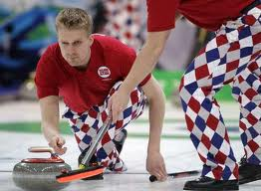

a. a slope

b. a sledge

c. a slide

a. a swan

b. a sword

c. a switch

a. curling

b. cordoning

c. pushing

The people who behave in an extremely violent way, especially at football matches:

A place where games such as tennis are played:

A player whose job is to stop the ball from going into his/her team’s goal is the:

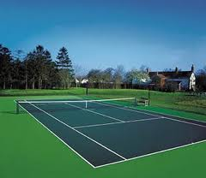

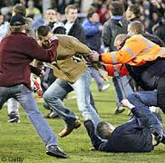

a. vandals

b. villains

c. hooligans

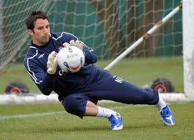

a. goalkeeper

b. doorkeeper

c. gatekeeper

a. court

b. course

c. counter

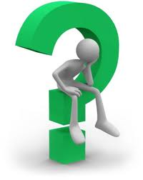

What’s the name of the object, shaped like a bottle, which players try to knock down in bowling?

How long is one lap of an athletics track?





When and where were the first Olympic Games celebrated?



What’s the generic name we use which includes sports like judo, karate, Tai Chi, etc.?



How many holes are there on a golf course?





What’s the adjective that means “healthy and strong, especially because you do regular physical exercise”?

How long is a marathon?



What’s the name of the game for 2 people played with 16 balls on a table?

What’s the verb which means “risking money on a sports event by trying to predict the result”?



__________________________________________________________________________________________________________

Give your answers here :