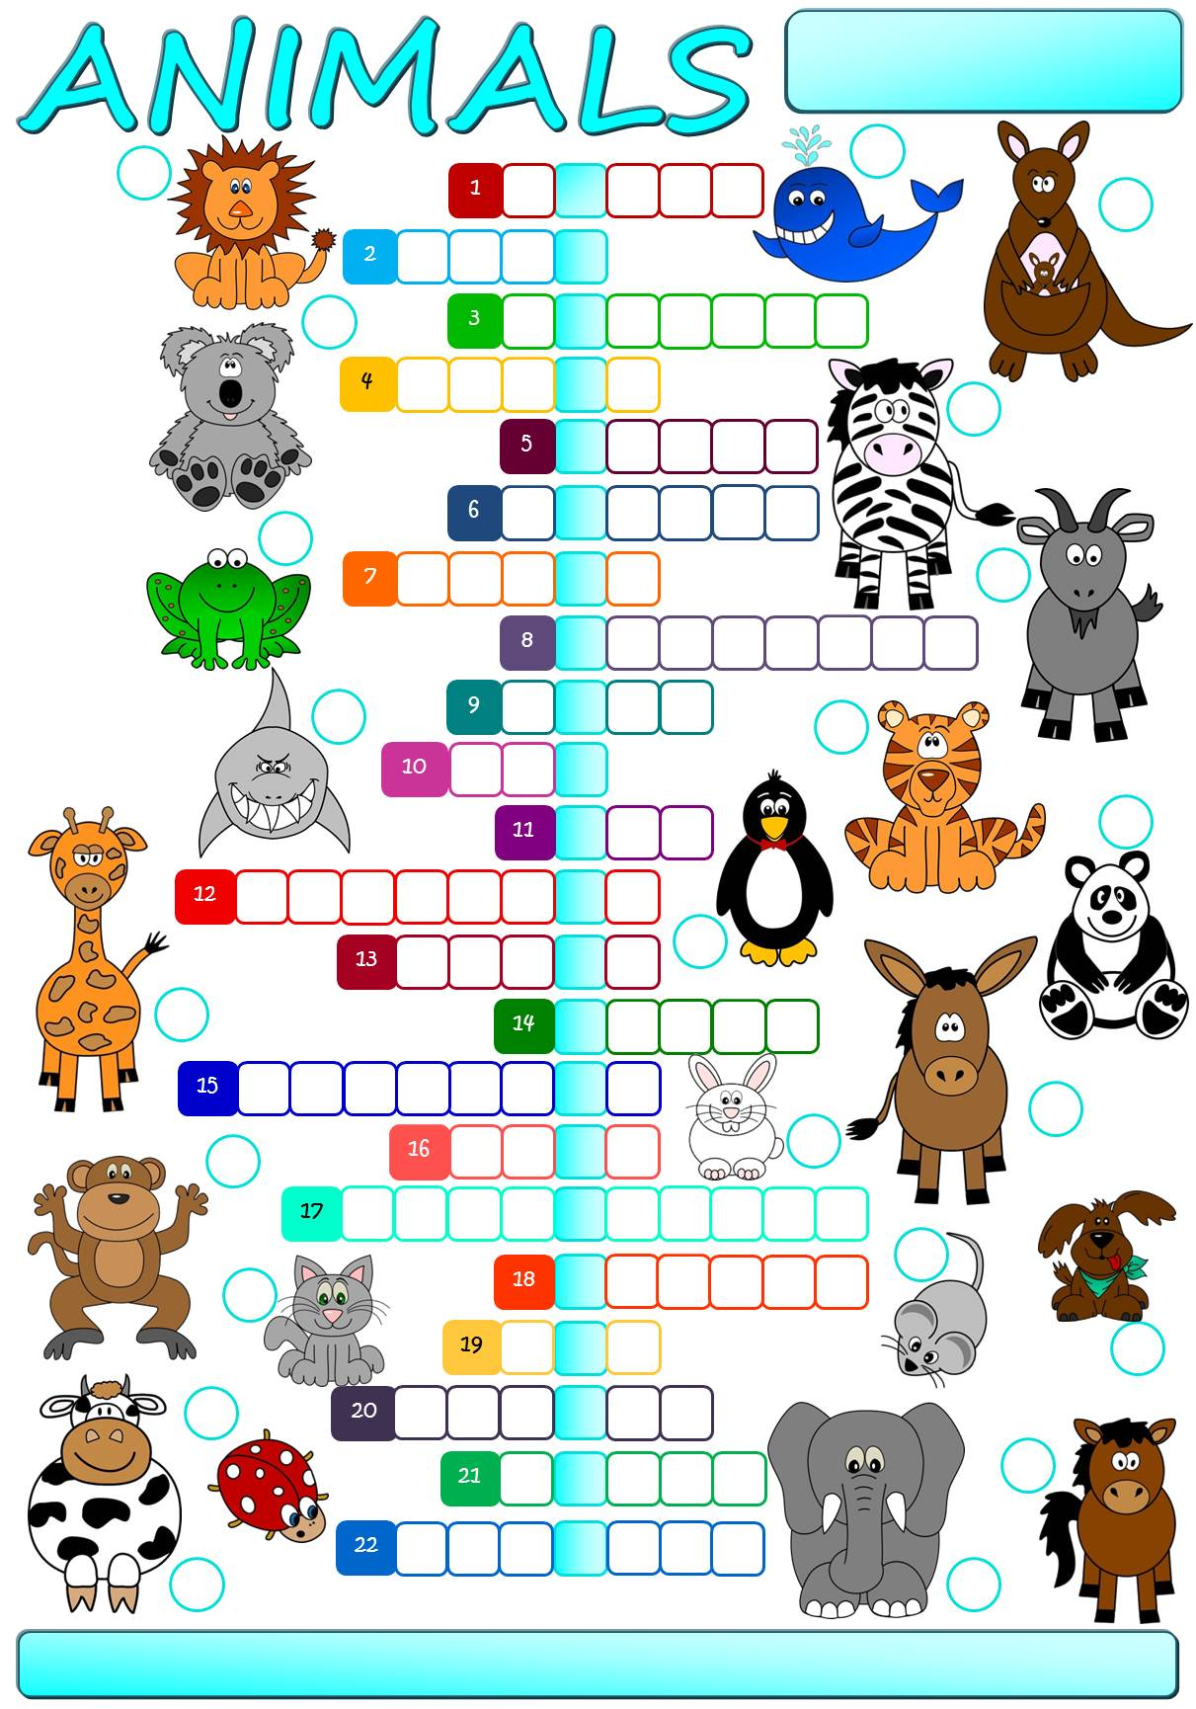

Year 4

Class: Machačová Yvona

**cat**

**cow**

**dog**

**donkey**

**elephant**

**frog**

**giant panda**

**giraffe**

**goat**

**horse**

**kangaroo**

**koala**

**ladybird**

**lion**

**monkey**

**mouse**

**penguin**

**rabbit**

**shark**

**tiger**

**whale**

**zebra**

The secret message is _________ __________ _________ _________ ________ ________ **summer.**